This Vietnam War vet will receive MoH for saving 10 soldiers
By Logan NyeJun. 13, 12:06 PM
Specialist 5 John C. McCloughan, a veteran of the Vietnam War and a retired teacher and sports coach, will receive the Medal of Honor in recognition of his actions during 48 hours of combat in Vietnam from May 13-15, 1969, the Army announced June 13.
During this time, McCloughlan was wounded multiple times but continued to give aid to troops under fire and pull them to safety.
McCloughan was part of Charlie Company, 3rd Battalion, 21st Infantry, 196th Light Brigade, in Vietnam in 1969 when Charlie Company was ordered to conduct a combat assault near Tam Ky and Nui Yon Hill.
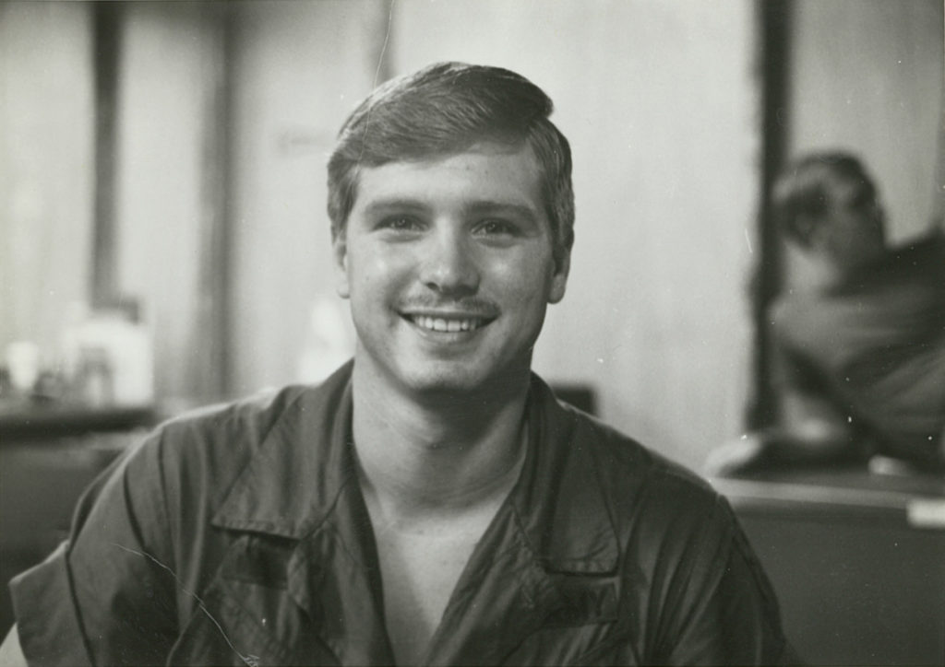
U.S. Army Pfc. James McCloughan, 1969. (Photo courtesy of James McCloughan
It was one of those missions that seemingly everything went wrong from the start, as two American helicopters were shot down and there was too much incoming fire for another helicopter to rescue the downed air crews. A squad was sent to conduct the rescue and recovery instead.
The squad reached the perimeter of the crash site and McCloughan ran 100 meters across open ground raked by fire to recover a wounded soldier, moving forward even as a platoon of enemy soldiers charged in his direction. McCloughan threw the wounded man onto his shoulder and rushed back to friendly lines as rounds raced both directions past him.

Later that same day, the young medic spotted two soldiers huddled together in the open without weapons. He handed his own weapon to another soldier and rushed forward even as American airstrikes hit known North Vietnamese Army positions all around him, Army records say.
As he examined the two men in the field, a rocket-propelled grenade struck nearby and pelted McCloughan with shrapnel. Despite his wounds, he pulled the two men back into a trench. He went back into the field to save wounded comrades four more times that day despite a direct order not to.

He was offered a spot in the medical evacuation because of his own wounds, but refused it, worried that the American forces would need a medic to continue fighting while outnumbered.
Early the next day, the only other medic on the field was killed in an NVA ambush, making McCloughan’s decision seem prophetic. In the intense fighting during the ambush, he was wounded a second time with shrapnel from another rocket-propelled grenade and small arms fire.
The Vietnamese then attempted to overwhelm the outnumbered Americans and launched a three-sided attack. McCloughan once again made trips into the crossfire to grab wounded soldiers and pull them back to safety. When American supplies ran low, he volunteered to move into the open with a blinking light to allow for a nighttime resupply drop.

On May 15, he distinguished himself once again by using a hand grenade to destroy an RPG position and treated wounded soldiers while engaging enemy forces.
McCloughan was credited with saving the lives of 10 members of his company throughout the 48-hour engagement.

